|  |
| --- |
| Circle Language Spec: Commands |

## Inactive Command Object Redirection in a Diagram

Inactive command object redirection is explained in the article *Inactive Command Object Redirection*. The current article demonstrates the concept in a diagram.

The picture below displays an inactive command, that redirects its definition to another inactive command.

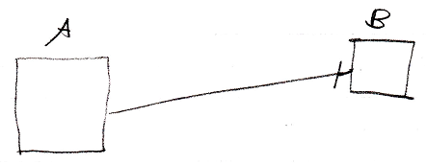

Inactive command symbol A is a square because it is an *inactive* command. Inactive command symbol A redirects to the inactive command symbol B. Symbol B is also a square because it is also an *inactive* command. The redirection from command A to command B is displayed as a solid line, which is an object line. The direction of the line is indicated by a line dissector, close to symbol B.

Symbol B could also be replaced by a diamond, because inactive pointers to active commands are allowed.

